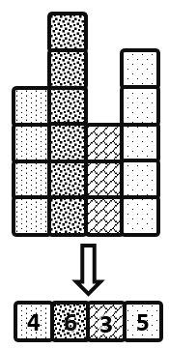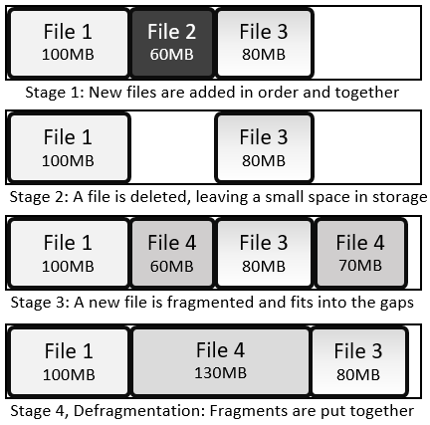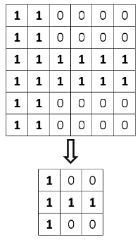

|  |  |
| --- | --- |
| **D** | **Prior Knowledge** |
| Operating System | |
| Utility | |
| Compression | |
| Encryption | |
| Malware | |

|  |  |  |
| --- | --- | --- |
| **C** | **Backup Types** | |
| **Full backup** | | All files and folders are copied when backing up |
| **Incremental Backup** | | All changes since the last incremental backup are saved. To restore, start with the full backup and then restore each incremental backup successively |
| **Differential Backup** | | All changes since the last full backup are saved. To restore, start with the full backup, then restore the latest differential backup |
| **Backup plan** | | A scheme of when and how to back up data |

|  |  |  |
| --- | --- | --- |
| **A** | **Utilities** | |
| **Anti-malware (software)** | | Software which prevents malicious software entering the system, identifies it when it is there and removes it |
| **Auto update** | | A utility which makes sure the utilities are up to date |
| **Backup** | | A copy of data and programs in case they are lost |
| **Compression software** | | Software which removes redundant data to reduce file size |
| **Defragmentation** | | Reorganising each file on a hard drive so it is all stored in one place, reducing the time the heads have to spend moving around |
| **Disk check** | | Search the hard drive for bad links and record those areas as unusable |
| **Encryption software** | | Software which encodes data to be stored or transferred |
| **System cleanup** | | Identify and remove unused or redundant files |

|  |  |
| --- | --- |
| **B** | **Fragmentation and Defragmentation** |

Software: Utilities

|  |  |
| --- | --- |
| **B** | **Compression** |